To be a successful project manager, you must be able to manage your time well. The best project managers ensure they are productive for most of their time and avoid time-wasters at all costs. Here are some tips that can help you manage your time more efficiently.

Create the Plan

What does this have to do with time management I hear you ask? Well, if everyone knows what they are doing and have a plan with regular milestones to focus on, you as project manager will spend a lot less time dealing with issues brought about by a lack of clarity.

Remember the 80/20 Rule

The 80/20 rule (or the Pareto Principle) is the idea that by doing 20% of the work you can produce 80% of the benefit of doing the whole job.

The value of this for a project manager is that it reminds you to focus on the 20 percent of activities that matter. Of the activities you do during your project, only 20 percent are important. Those 20 percent produce 80 percent of your results. Identify and focus on those activities.

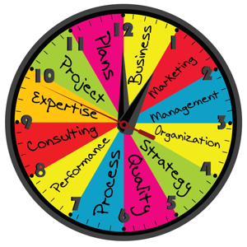

Not Just Status Updates

It's best to avoid team meetings where you go around the room asking each person to give a status update. These meetings have little value and waste time. Instead, spend that time focusing on risks, issues and opportunities. Use the team to brainstorm solutions and create ideas.

Have an agreed agenda that you stick to in team meetings. If you schedule an hour for the meeting, make sure it lasts for an hour and no longer.

Take significant issues off-line if they are likely to cause a meeting overrun. Don't make everyone sit through lengthy technical discussions that don't involve them. Set up a working group to focus on the issues and report to the team at a future meeting.

Stop Micro Managing

Avoid delving into the detail of the work. With software development projects, it's not necessary for the project manager to get involved at the code level, leave this to the developers. You've selected the right team for the job. Let them get on with what they are best at, while you concentrate on steering the project to a successful conclusion.

Don't Do the Work

Many project managers make the mistake of getting involved in 'doing the work'. Avoid this at all costs. Managing projects is a full-time job and taking your eye off the ball (even for a short period) can lead to problems. It may be tempting to carry out a few tasks when a deadline is looming, but leave this to others while you get on with managing the project.

Create a To-do List

Email fixation is a modern-day problem that can distract you from doing the tasks you need to, or plan to. Creating a daily to-do list keeps you focused on achieving your objectives. Scratching tasks from your list can create a real sense of achievement and drives further activity.

Summary

Time management is an essential skill for project managers. If you can't manage your own time, how can you expect to manage your teams? Ask each day what you did to move the project forward. Plan your next day, what will you do to ensure your project continues along the straight and narrow path. Plan your time, manage your resources with a light touch and communicate effectively. With a little time management, project success should come easier.